Part One
Inspect your RS-1000 Generator

AFFECTED PRODUCTS: RS-1000 (9100652)

DIRECTIONS: Prior to installation of the RS-1000 spray tubes, fill out the “RS-1000 Generator Inspection Form” to submit your generator’s current unit condition. Only one form is required per store.

RS-1000 Generator Inspection Form

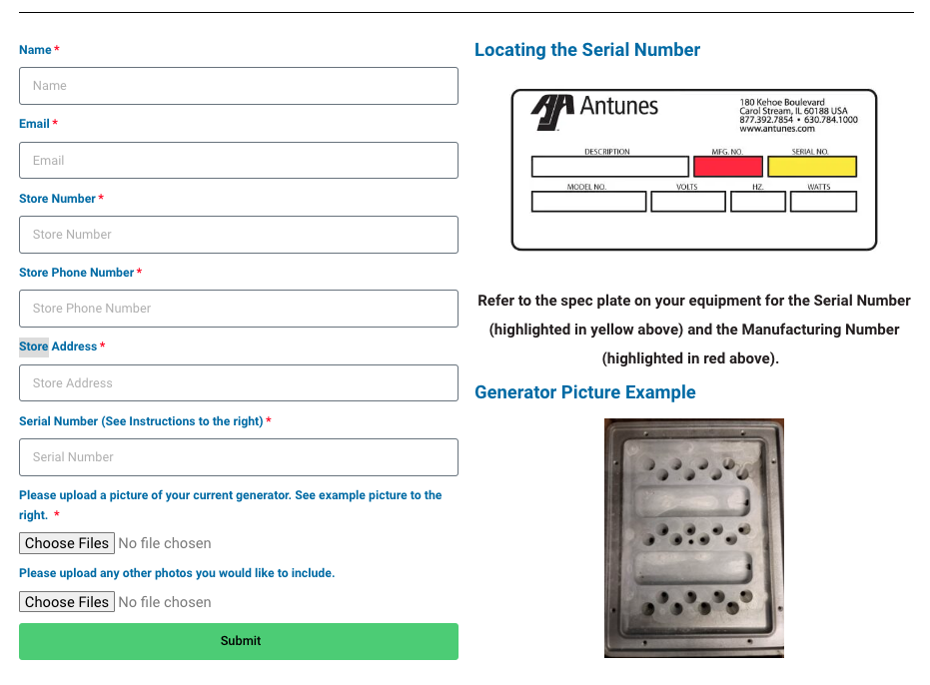

Scan the QR Code for the
RS-1000 Generator Inspection Form
or use the link below

https://antunes.com/noodlesco/inspection/

Part Two
RS-1000 Spray Tube Installation Instructions

AFFECTED PRODUCTS: RS-1000 (9100652)
PARTS INCLUDED:
2 – Spray Tube Assembly (P/N XXXXXX)
1 – Cleaning Tool (P/N 0014808)
1 – Installation Instructions
General  If you experience any problems with these instructions, or if any parts are damaged or missing, contact the factory Technical Service Department 877-392-7854.  - Turn the power switch OFF; allow the unit to cool down then unplug power cord.  - Remove the Top Cover, Wing Nut, Support Channel, Generator Cover Assembly and Diffusers to access the Steam Generator (Fig 1).  - Using the Cleaning Tool ensure that the Horizontal Steam Ports (Fig 2) are clear of any debris/build up (Fig 3).  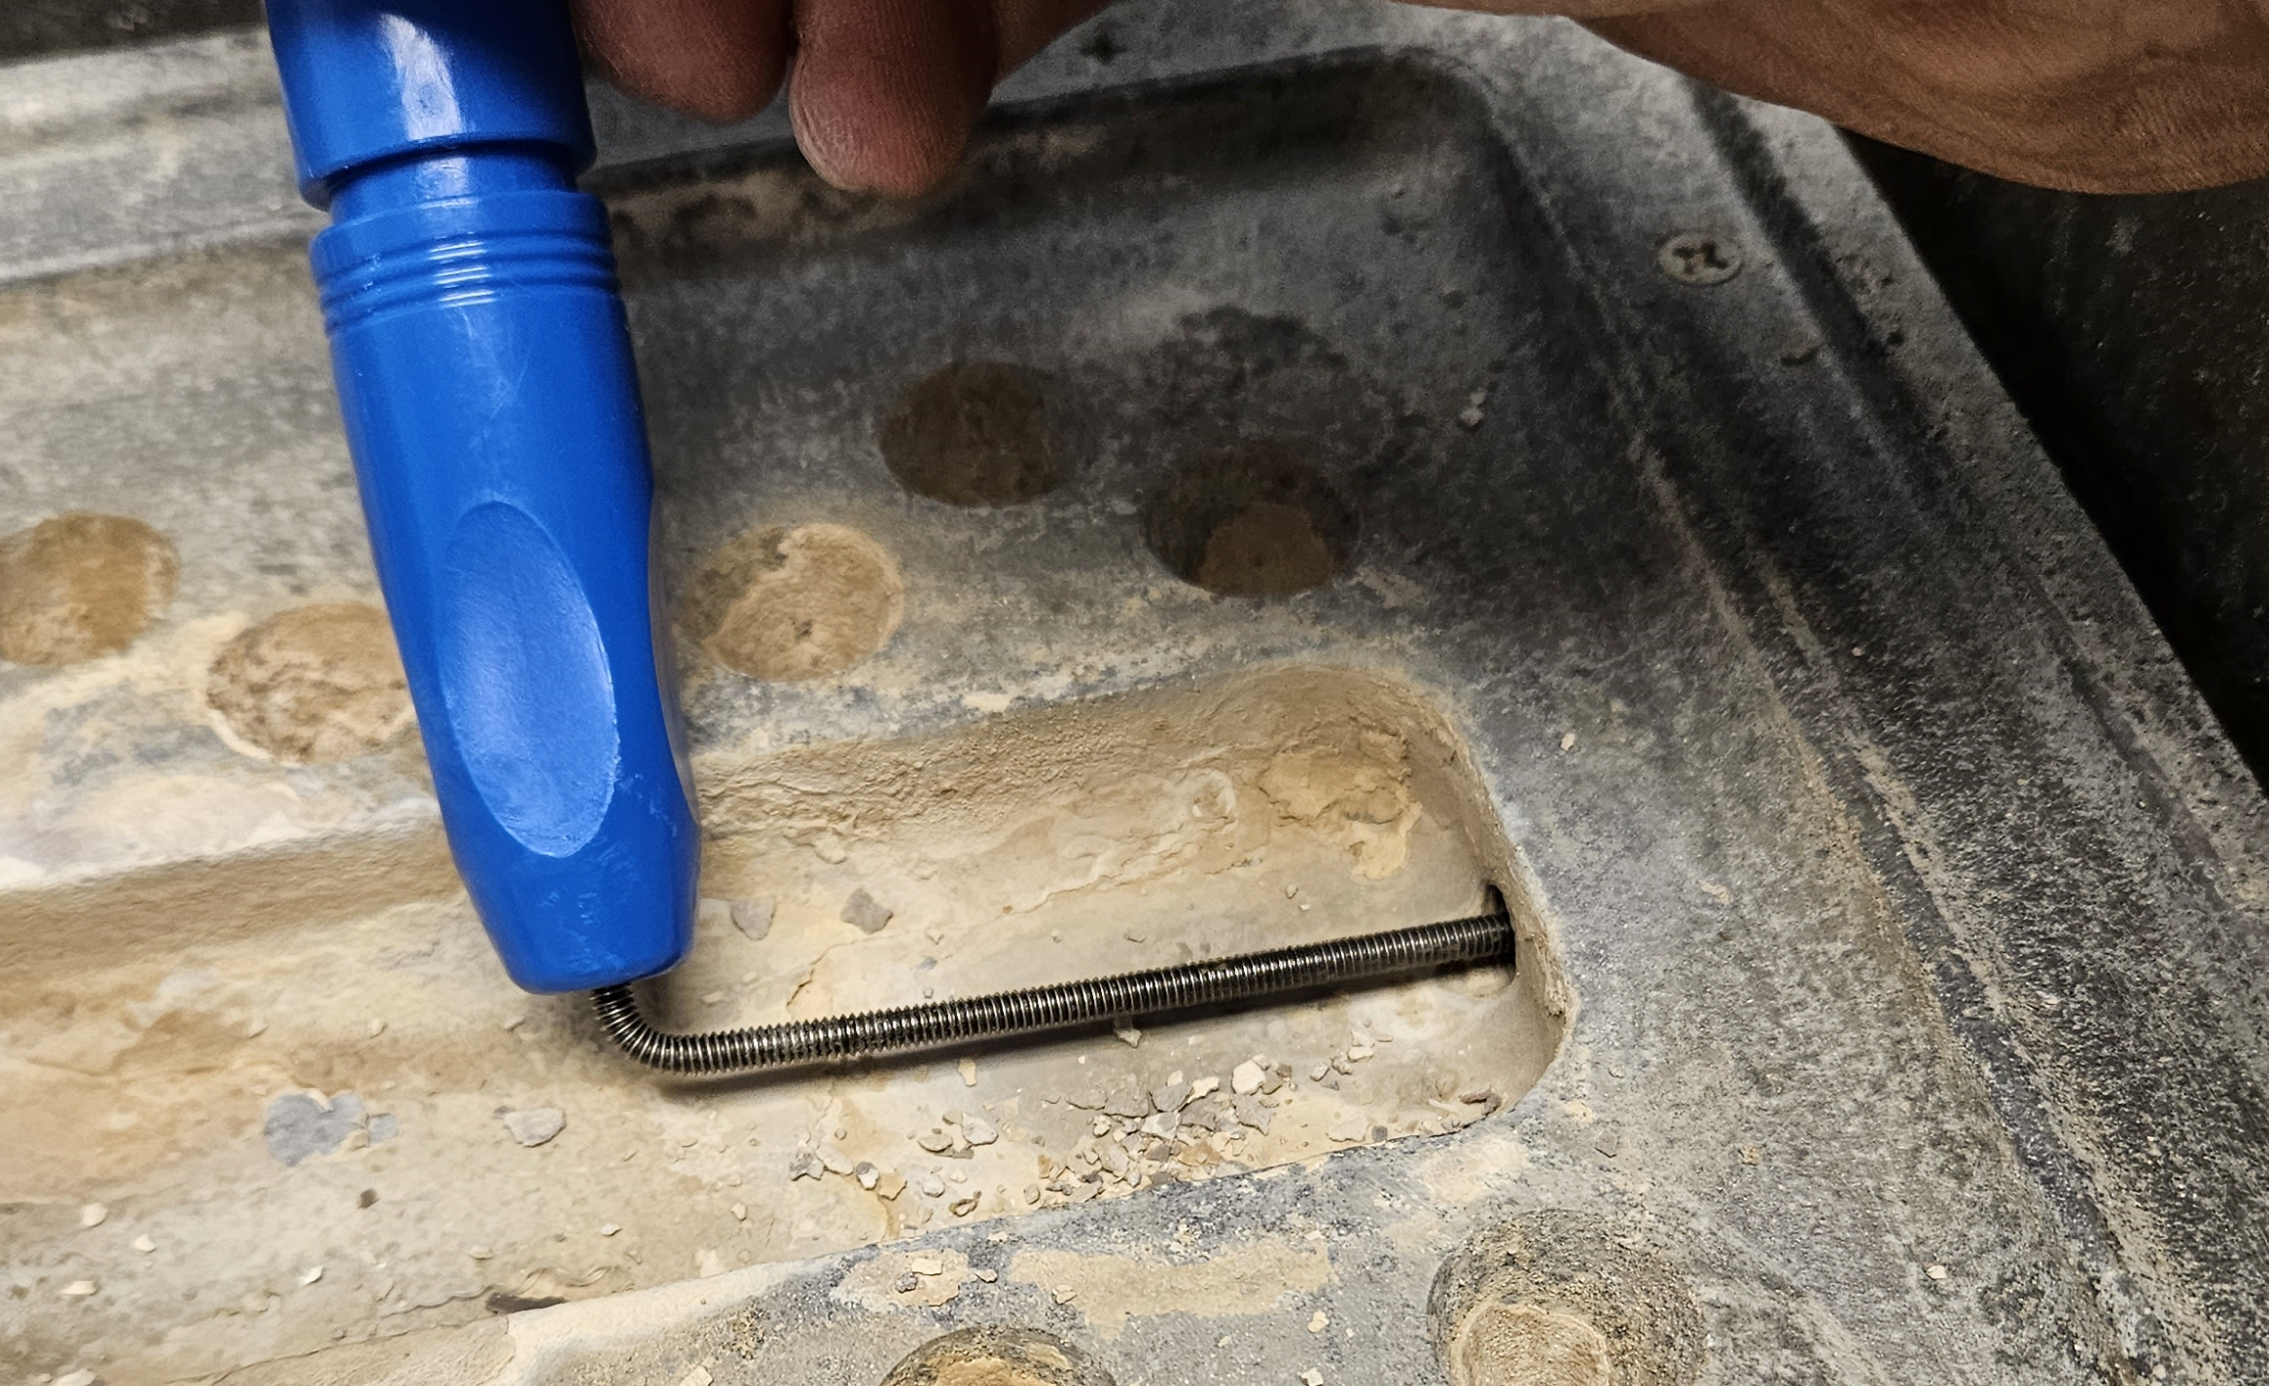  Figure 3. Cleaning Horizontal Steam Ports  - Once the Horizontal Steam Ports are clear, install the spray tube assembly. First insert one end of the Spray Tube in the Horizontal Port first (Fig 5) and then lay the spray tube down so that the tube is approximately ½” from the water trough on the non-control side. There should be approximately ½” Teflon tube protruding from the Spray Tubes Steel Sleeving (Fig 4).  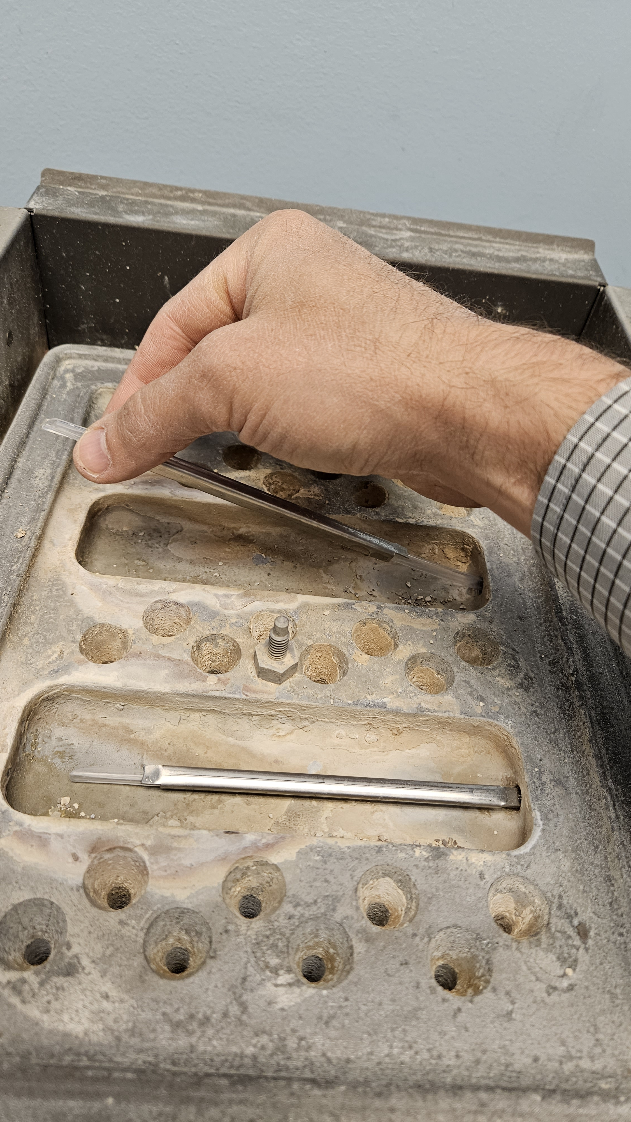  Figure 5. Inserting Spray Tube | 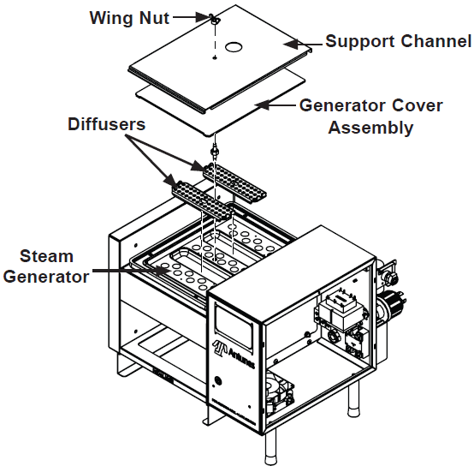  Figure 1. Accessing the Steam Generator  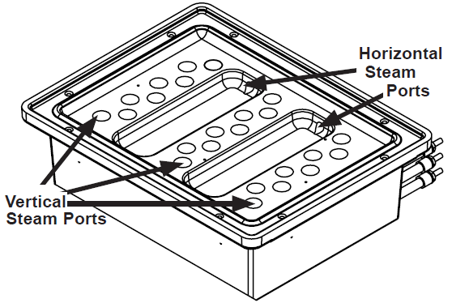  Figure 2. Generator Steam Ports  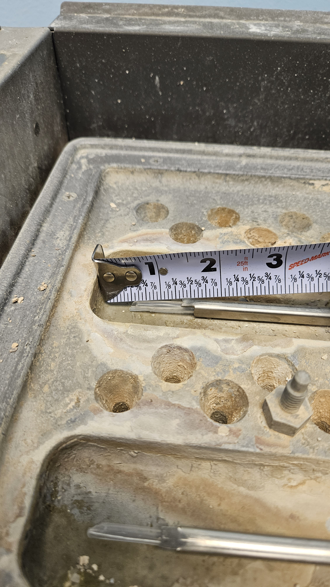  Figure 4. Measuring Spray Tube  